1. USER - REGISTRATION

1.a Registered Successfully

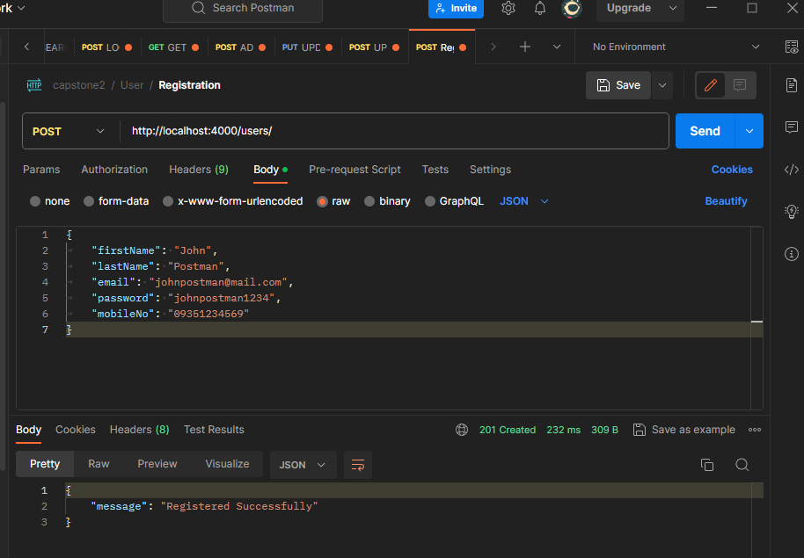

1.b Error – password must be 8 characters or more

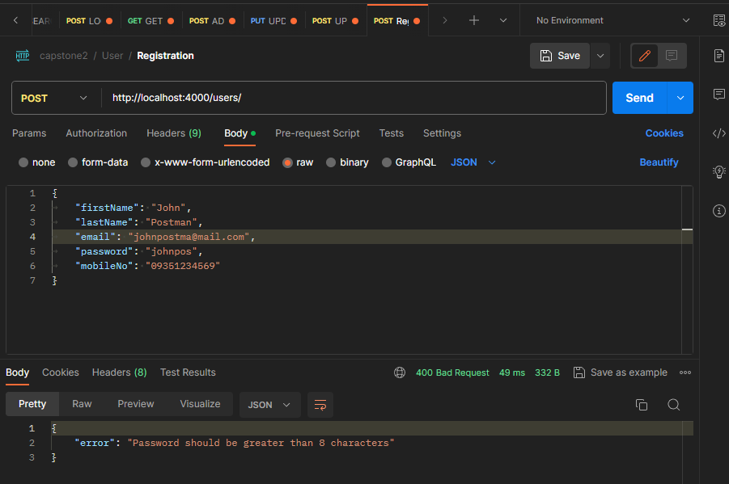

1.c Error – mobileNo not 11 digits

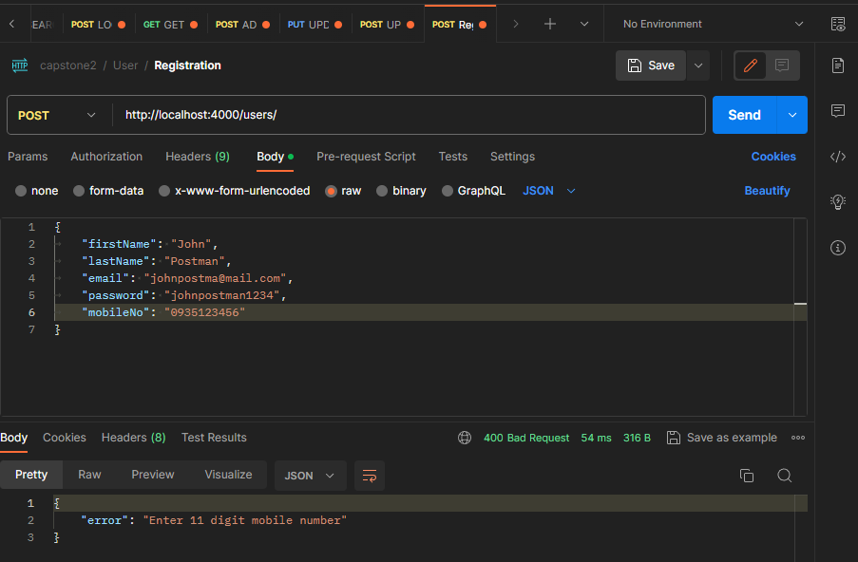

1.d Error – Email has no @ symbol

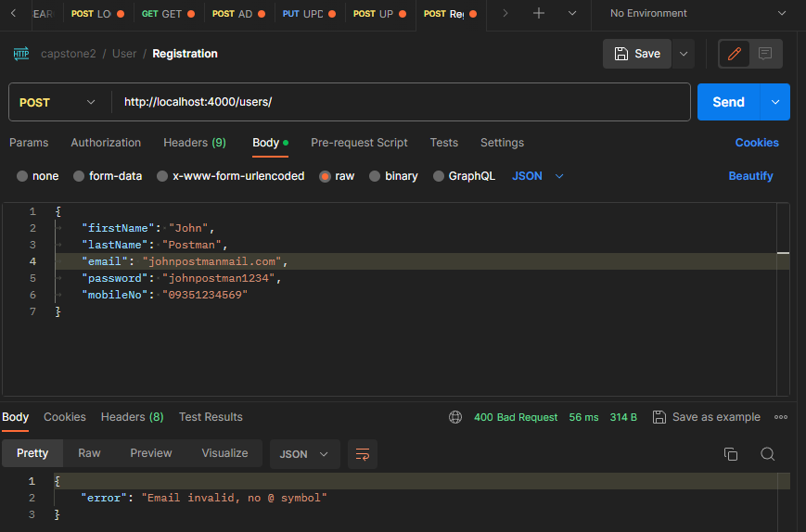

1.e Error – Duplicate email or user found

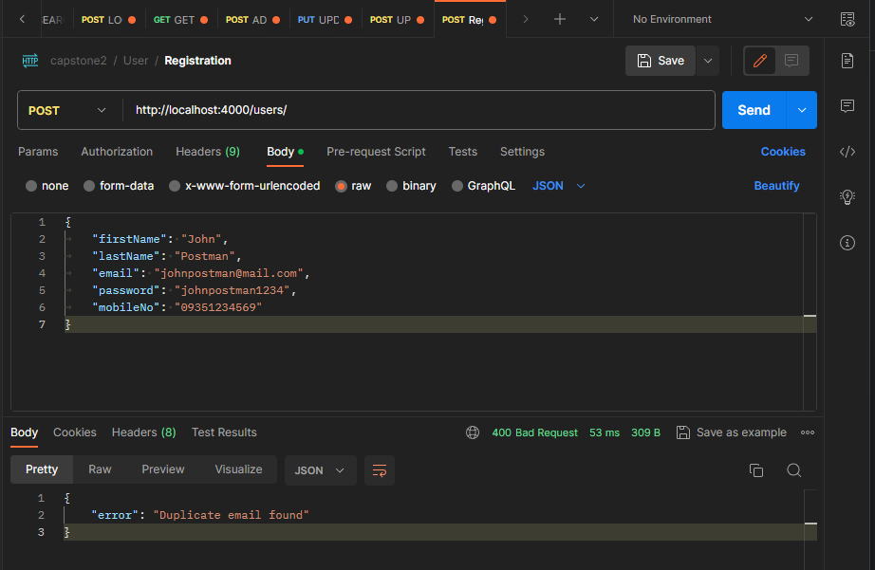

1. USER - LOGIN

2.a Login Successfully

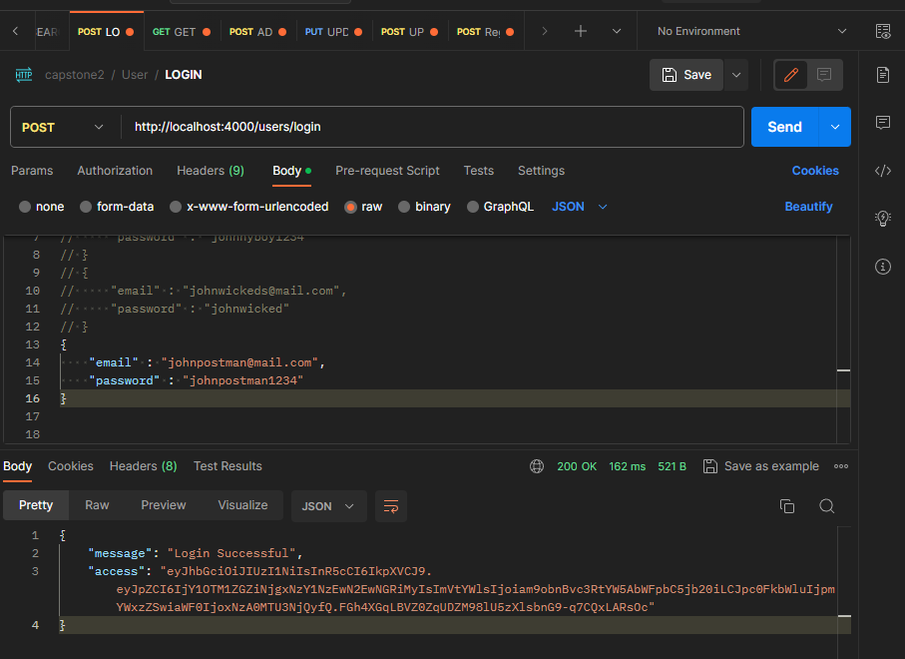

2.b Error – no email found

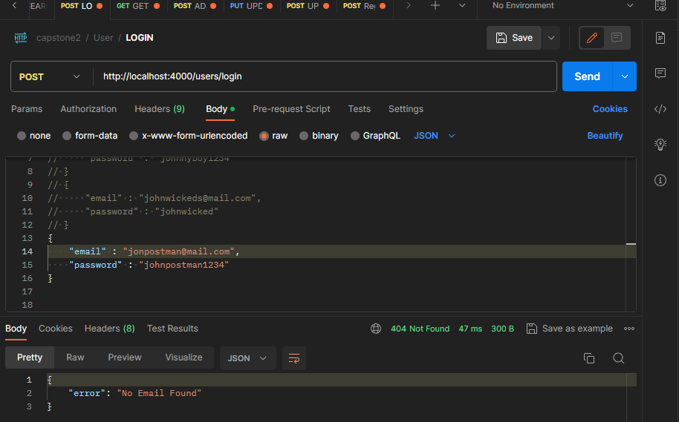

2.c Error – email and or password do not match

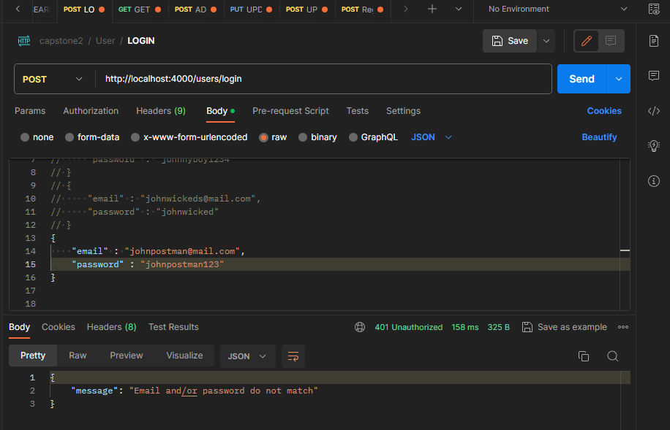

1. USER - RETRIEVE USER DETAILS

3.a Retrieve user details success

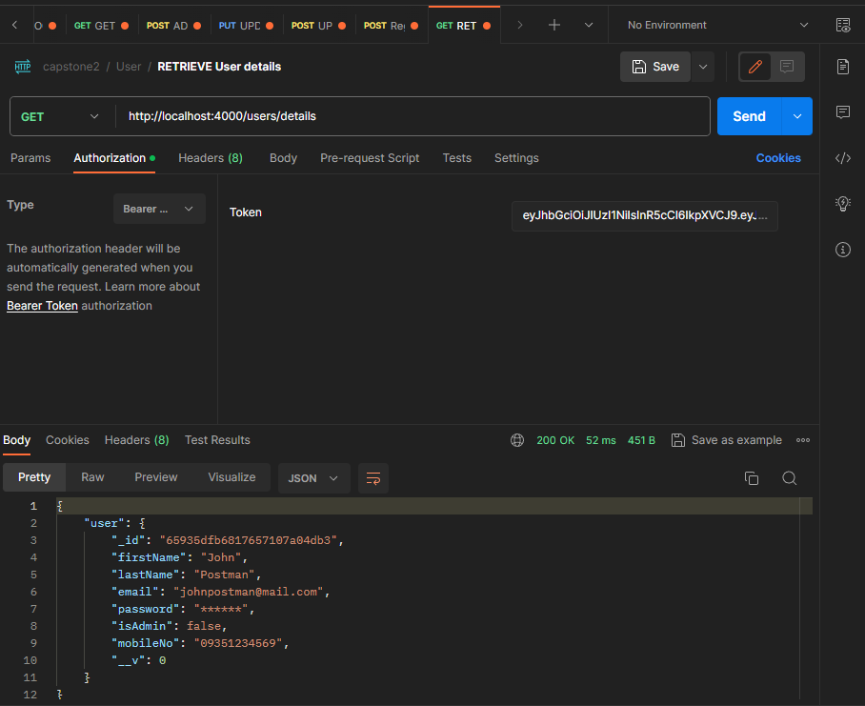

1. USER - UPDATE USER TO ADMIN

4.a user updated to admin using admin account

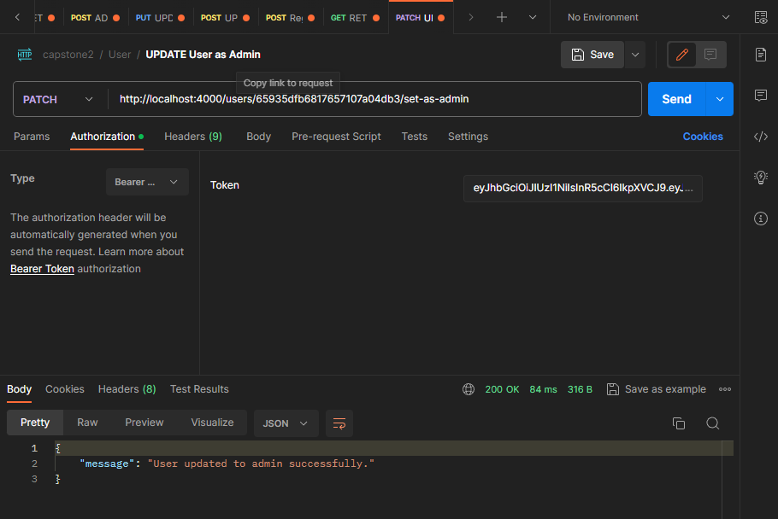

4.b isAdmin status was changed from false to true using the retrieve user details

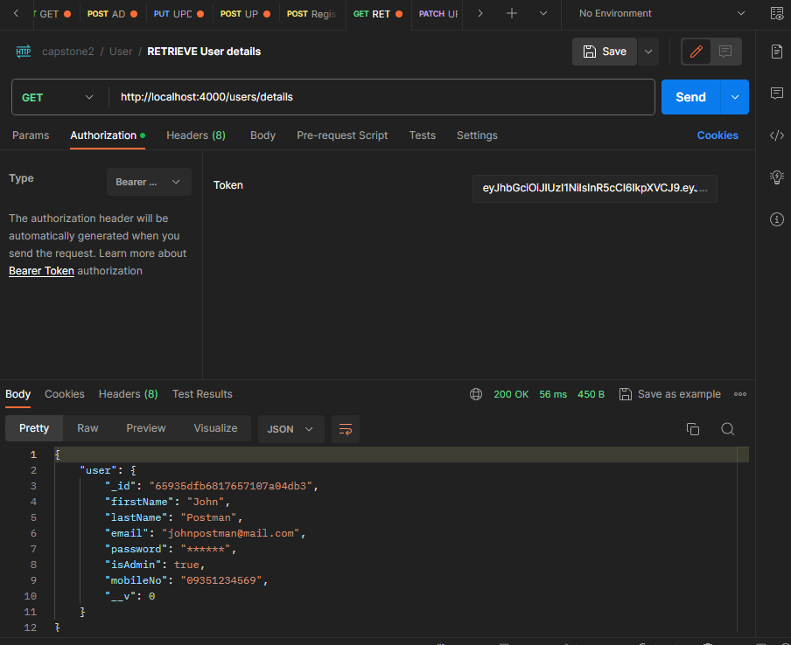

4.c Error – user not found

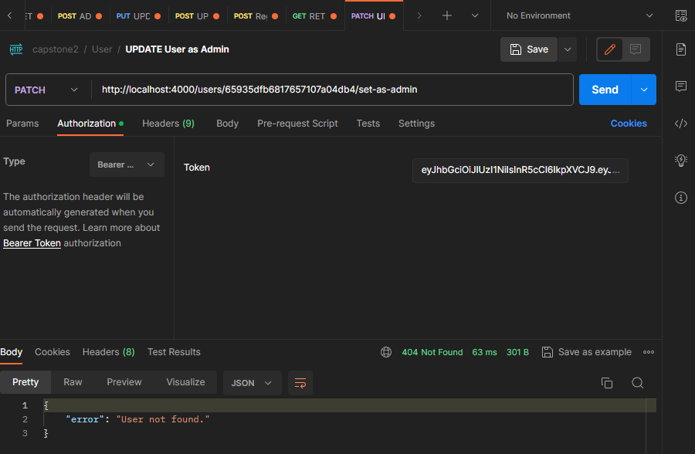

1. USER - UPDATE PASSWORD

5.a Update password success

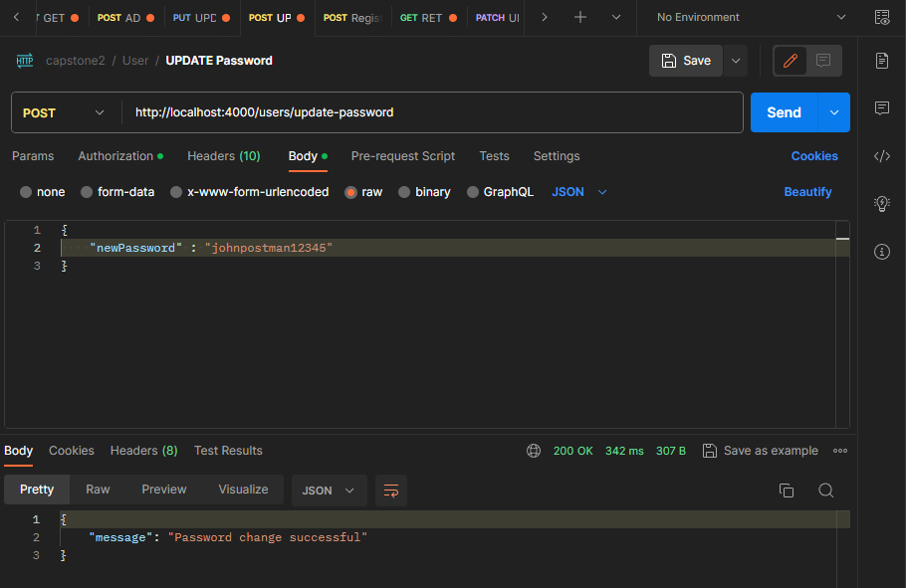

5.b Error - Password should be at least 8 characters

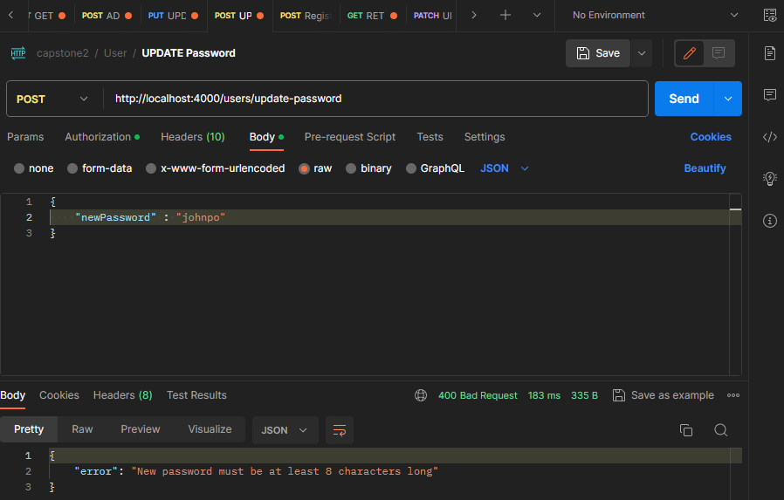

5.c Error - New password should be different from the old password

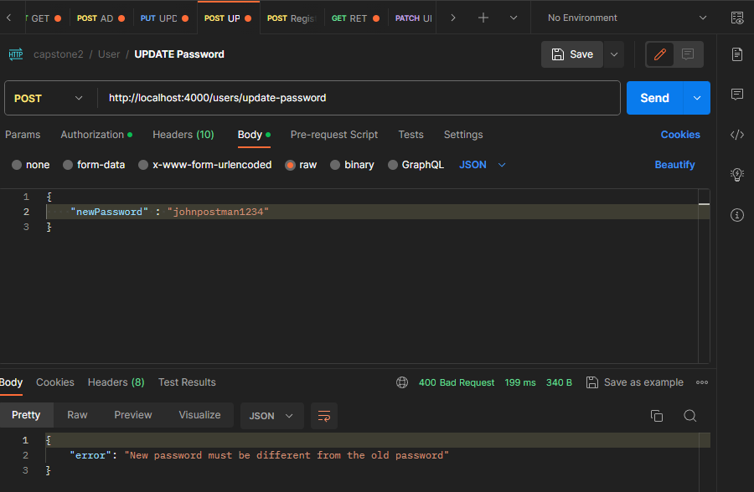

1. PRODUCT - ADD PRODUCT

product added successfully using admin account

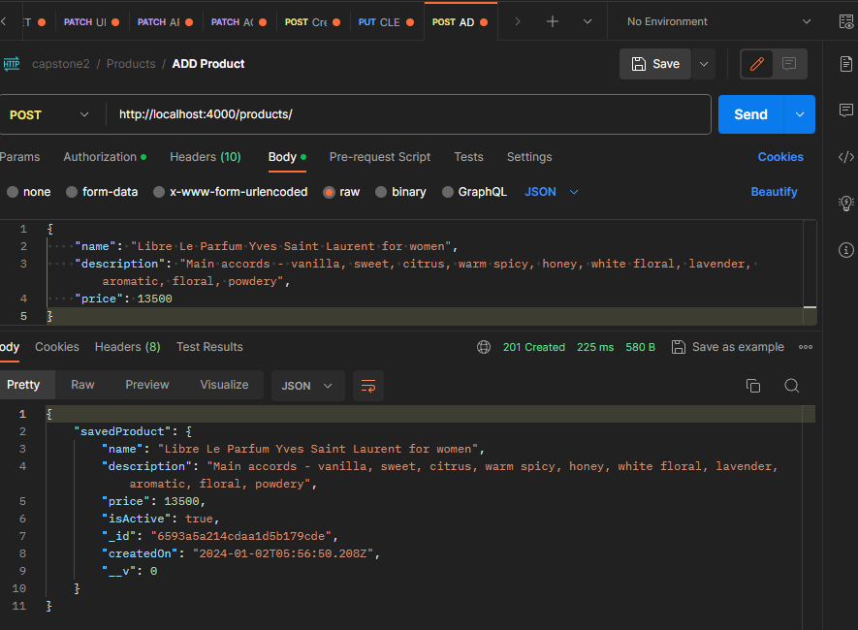

1. PRODUCT - GET ALL PRODUCTS

Get all products in the database

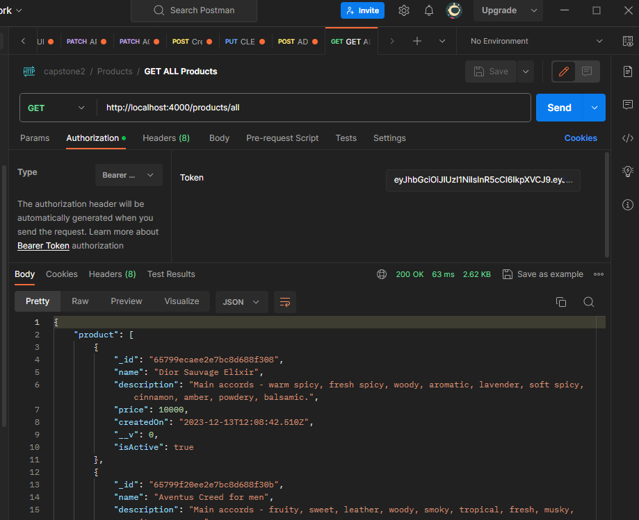

1. PRODUCT - GET SPECIFIC PRODUCT

Get specific product in the database using productID

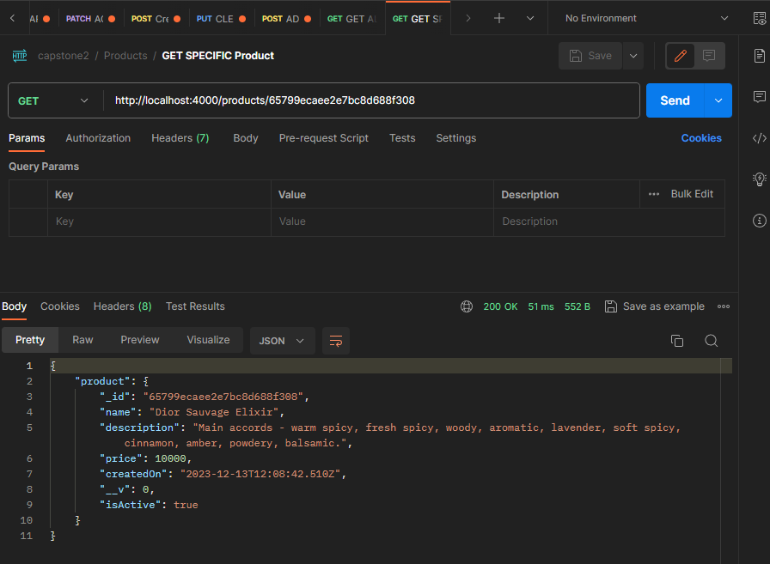

1. PRODUCT - GET ALL ACTIVE PRODUCT

Get all isActive : true in the database

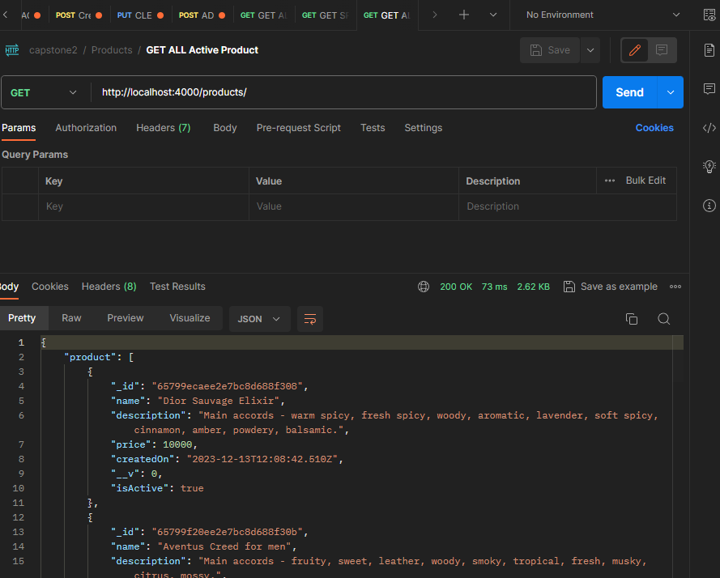

1. PRODUCT - ARCHIVE PRODUCT

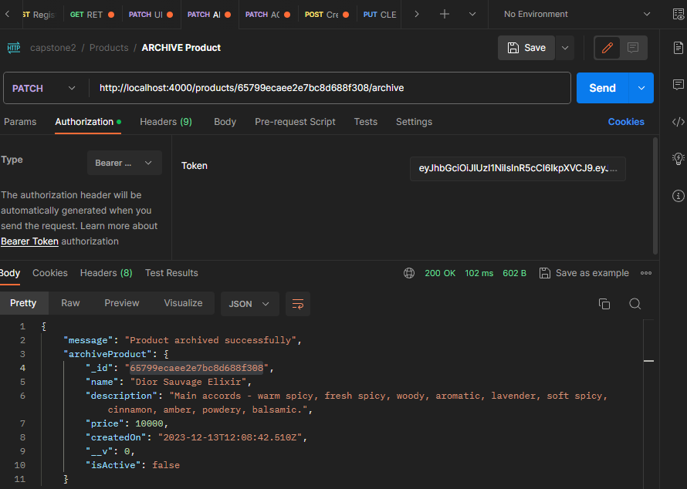

1. PRODUCT - ACTIVATE PRODUCT

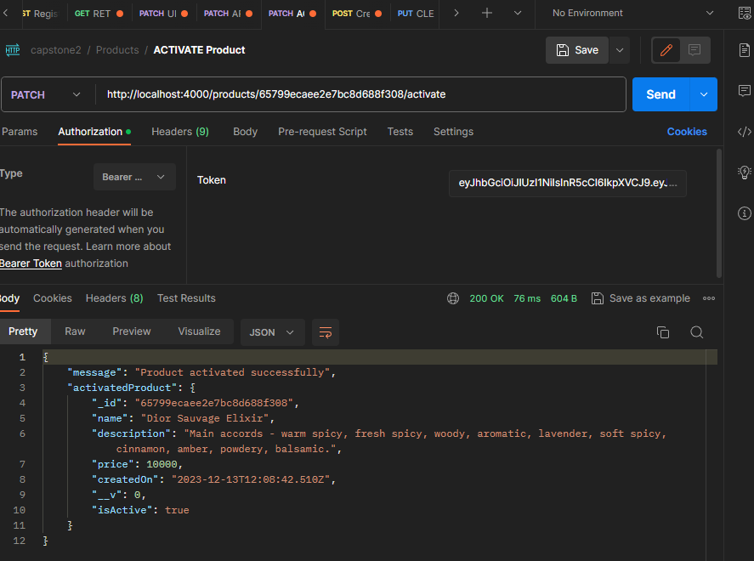

1. PRODUCT - UPDATE PRODUCT

Product updated from 13,500 to 14,000

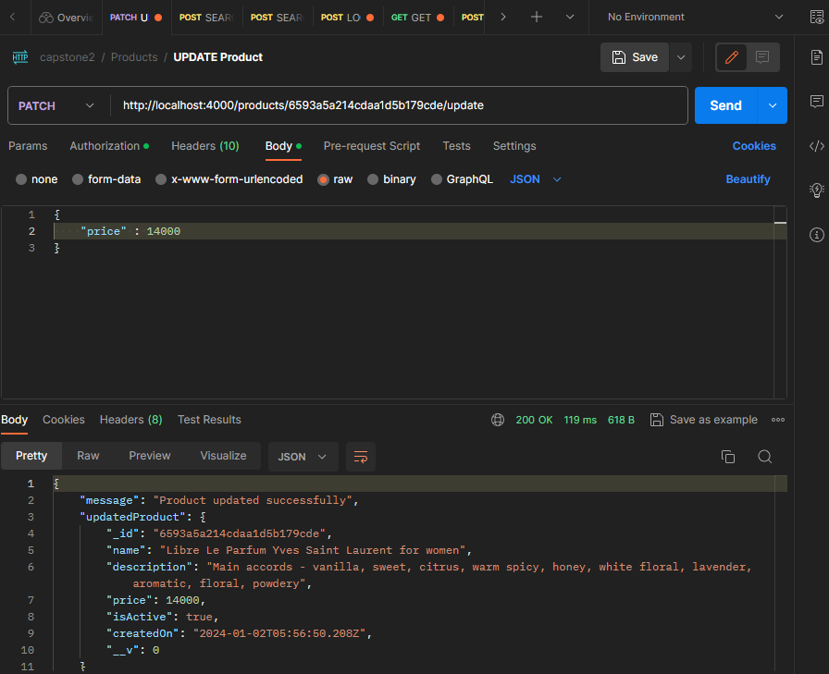

1. PRODUCT - SEARCH BY PRICE RANGE

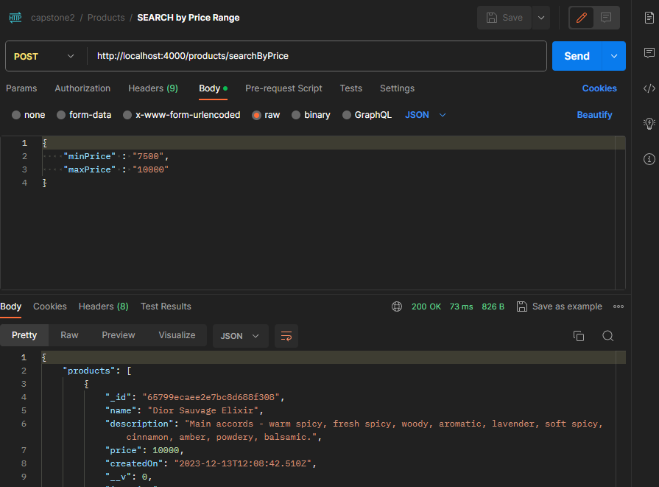

1. PRODUCT - SEARCH BY NAME

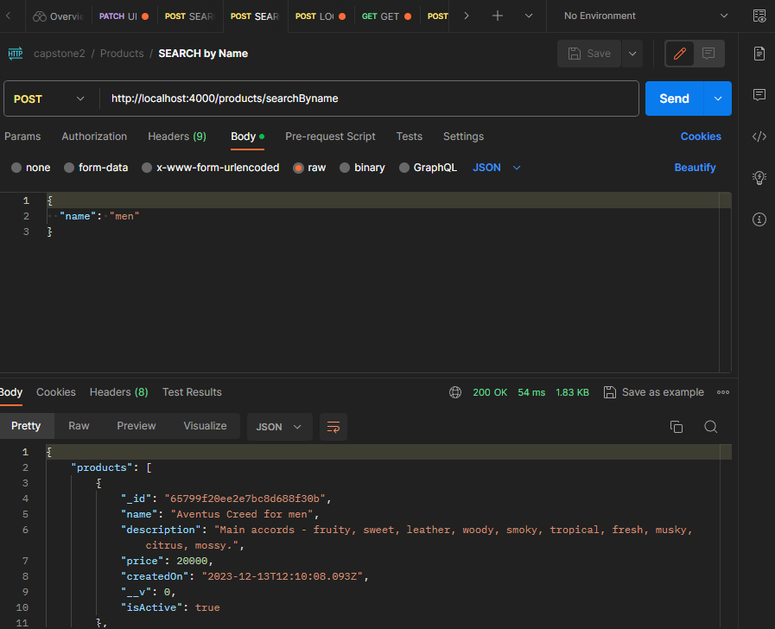

1. CART – GET CART

15.a Initial cart (empty)

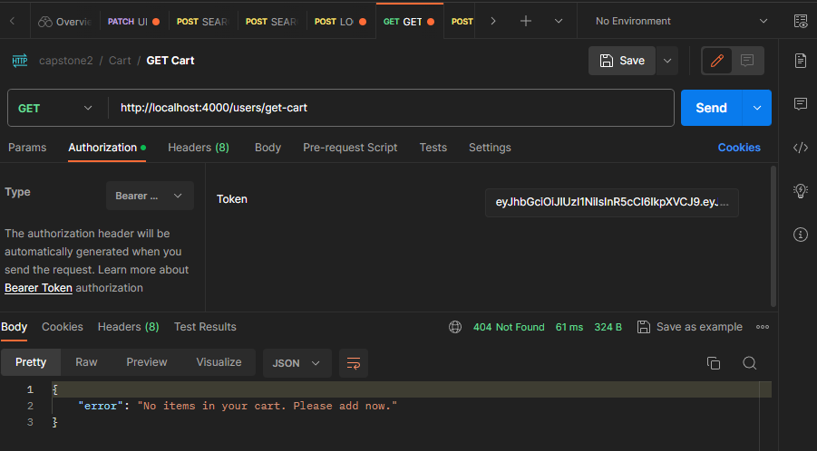

15.b Cart with added items

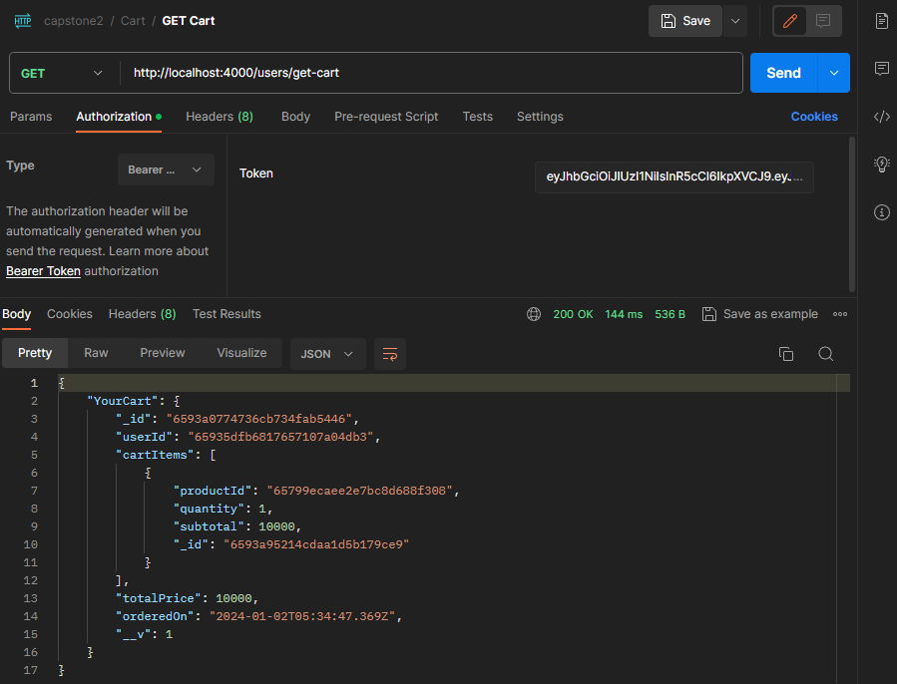

1. CART - ADD TO CART

16.a ADD TO CART

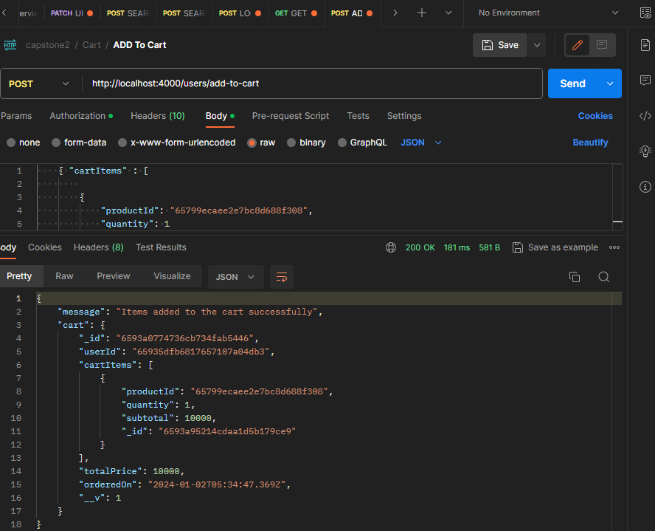

1. CART - UPDATE QUANTITY

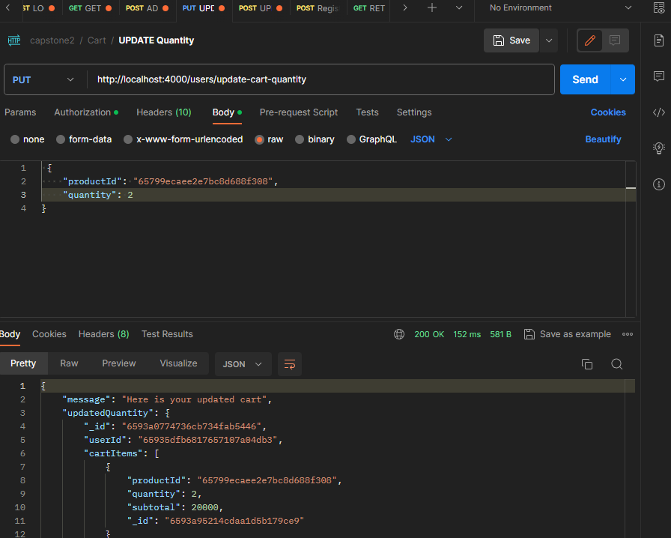

1. CART - REMOVE ITEM IN CART

The item with id in the URI was removed

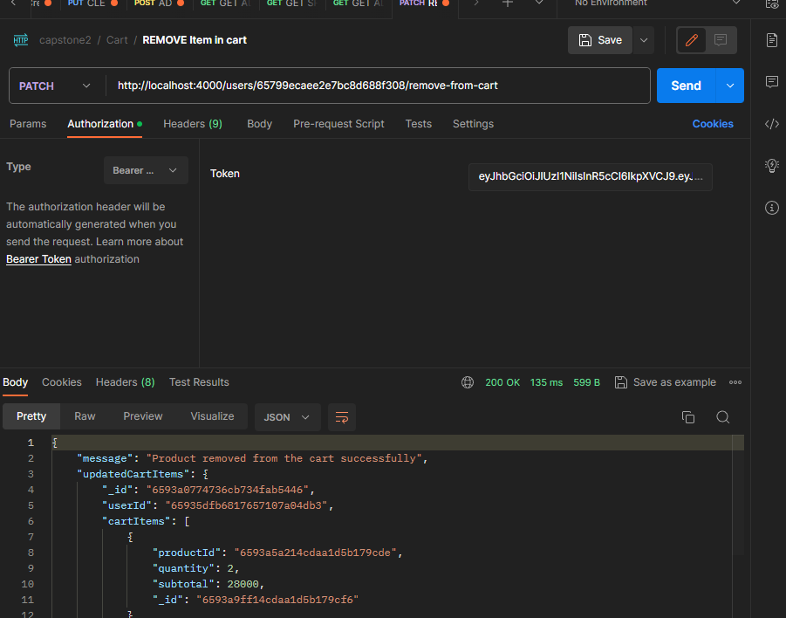

1. CART - CLEAR CART

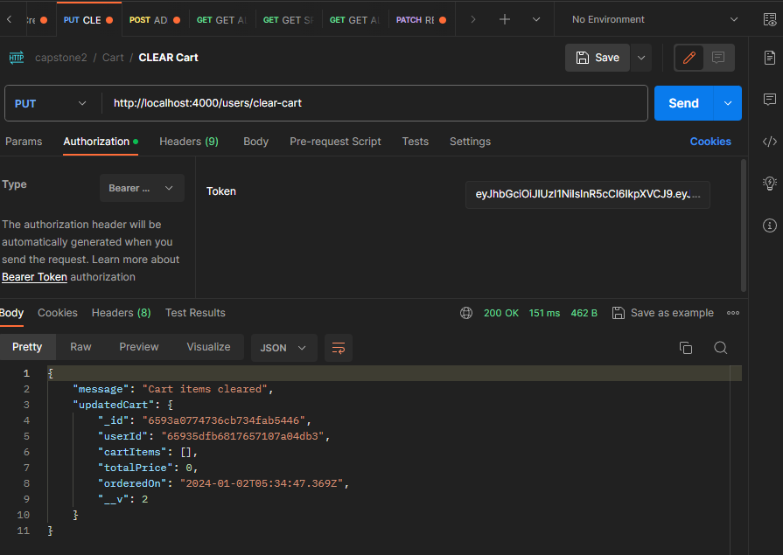

1. ORDER – CREATE ORDER

Order was created using the items in users cart

Likewise deleting the items in the cart

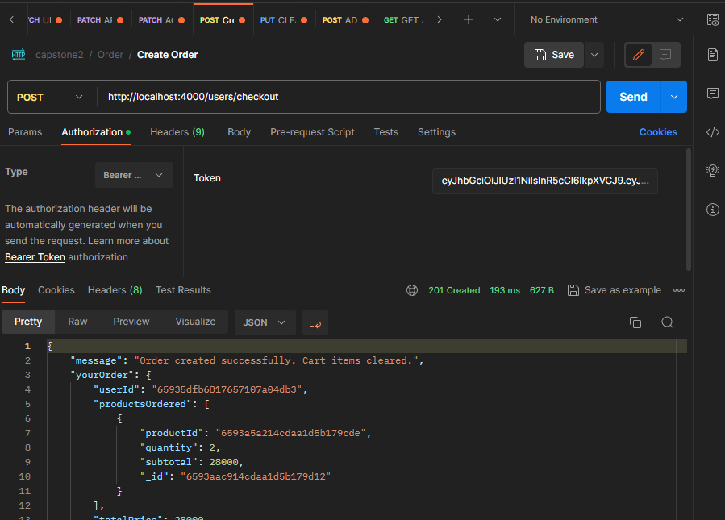

1. ORDER - GET ALL ORDERS ADMIN

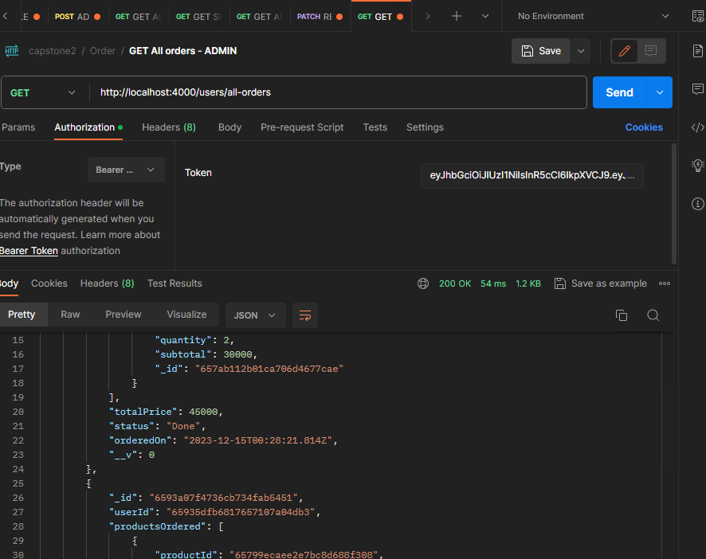

1. ORDER - GET USERS ORDER – USER

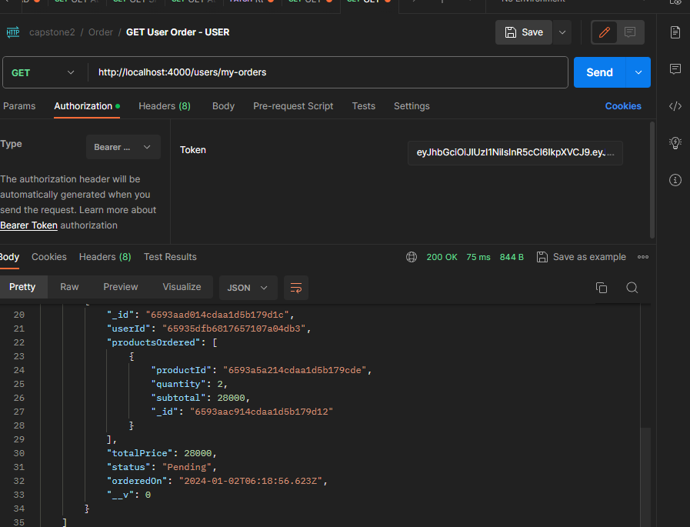

1. ORDER - UPDATE STATUS OF ORDER

Status changed from pending to done

